**ANNUAL REPORT 2021/2022**

****

[**withingtonassist@gmail.com**](mailto:withingtonassist@gmail.com)[**www.withingtonassist.org.uk**](http://www.withingtonassist.org.uk) **439 Wilmslow Road,  
 0161 434 9216 Registered Charity No: 1062675 Withington, M20 4AN**

**CONTENTS  
  
 Who we are   
  
 What we do  
   
Chairs Report   
  
Quotes and Feedback  
  
Coordinators Report  
  
Commemorations  
  
Easing out of Covid  
  
Financial Breakdown  
  
Thank you to all our funders**

**WHO WE ARE ….**

**STAFF (as of March 2022)**

**Coordinator Cook Administrator OPeNs Worker**

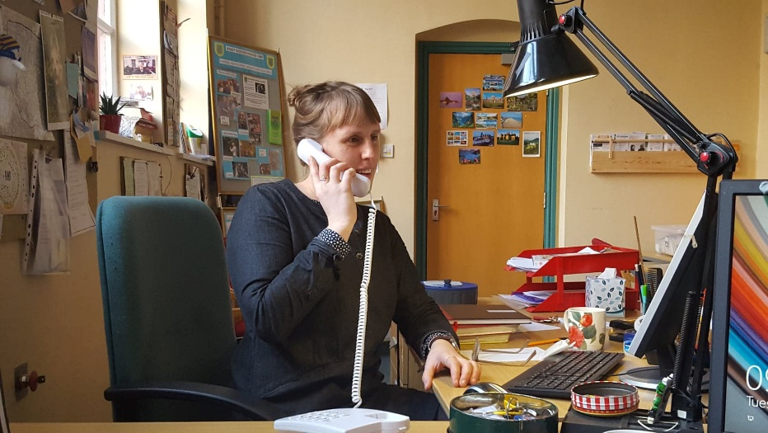 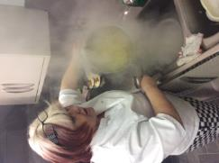 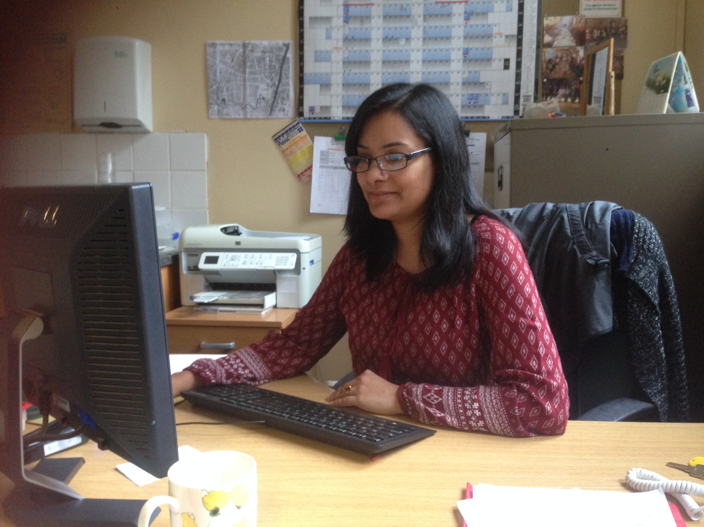

Amelia King Debbie McGowan Mousumi Sengupta Emma Horridge

|  |  |
| --- | --- |
| **TRUSTEES (March 2022)**  **CHAIR**  Pip Cotterill  **TREASURER**  Vicky Wharmby  **SECRETARY**  Sarala Gunawardena | Libby Spencer  Jacqueline Kirkby  Geraldine Yorke  Margaret Redhouse  David Lamb  Gavin White  Brian Stevenson  Barbara Aston  Brenda Barnett |

**VOLUNTEERS (as of March 2022)**

|  |  |  |  |  |  |
| --- | --- | --- | --- | --- | --- |
| Amy | Adams | Bob | Dolan | Hemangini | Natarajan |
| Pauline | Ainscough | Faith | Escreet | Pattie | O'Donovan |
| Pip | Aspin | Deborah | Farrel | Brendan | O'Dornan |
| Barbara | Aston | Rose | Godkin | Bridget | O'Dornan |
| Noreen | Barlow | Lucy | Goodman | Rachel | Pattinson |
| Brenda | Barnett | Sarala | Gunawardena | Margaret | Redhouse |
| Rosalind | Blackman | Baharak | Jooshandeh | Nicole | Rhodes |
| Paul | Borger | Jacqueline | Kirkby | Daka | Soal |
| Jane | Brown | David | Lamb | Libby | Spencer |
| Jackie | Callow | Cal | Lavelle | Brian | Stevenson |
| Rozalia | Cherif | Ray | Lavelle | Freddie | Von S L |
| Pip | Cotterill | Sally | Lee | Vicky | Wharmby |
| Kathryne | Cowhig | Felicity | Markland | Gavin | White |
| June | Critchley | Marlene | McCarthy | Tom | Williams |
| John | Crocker | Angela | McCormick | Geraldine | Yorke |
| Danny | Daly | Ellen | Meredith |  |  |
| Elisabeth | Diamant | Joyce | Murphy |  |  |

*Volunteer wheelchair training*

**WHAT WE DO .…**

Assist Neighbourhood Care is a community and voluntary organisation based in Withington, South Manchester. Our priorities are to reduce social isolation in the community, provide volunteering opportunities and enable older people to continue living independently.

Running since 1969 we have helped hundreds of older people living locally through befriending, attending social activities and support services.

As a registered charity we are funded in part by Manchester City Council who cover salaries and some overheads. All other costs are raised from fundraising, through grants and donations.

**SOCIAL GROUPS SUPPORT SERVICES**

In person befriending  
Telephone befriending  
Lawn mowing and hedge trimming  
Signposting  
Advice and Advocacy  
Form filling  
Hospital lifts  
Odd jobs  
Wheelchair loan   
Emergency Shopping

Lunch Club  
Coffee Group  
Exercise Classes  
Positive Living Sessions  
Film Club  
Tea and Talks  
Day Trips  
Volunteer training and get togethers  
Older men’s snooker group  
Digital Drop In

*Outdoor group of six meeting for   
  
 coffee in April 2021*

**CHAIRS REPORT**

I would like to thank our staff, volunteers, Board members and service users for ensuring that Assist kept going and even expanded in 2021-2022. Towards the end of the year Amelia was on maternity leave, and we welcomed Meena as her replacement. She has fitted in really well. Manchester City Council has continued their economic support and we thank them most sincerely. Nearly 200 older people living in the Withington area, the vast majority of whom live alone, are supported by us and we are really pleased we can help them.

Pip Cotterill - Chair of Board

**QUOTES AND FEEDBACK**

*Having moved to the area 5 years ago, I still hadn’t joined any classes until I had a stroke and needed to come to the Assist exercise class and found out about Positive Living sessions. It has helped in my daily life by learning how to cope with what life throws at us. Meeting people who are very welcoming and friendly. I love the everything about the classes, Deborah has such a positive bubbly attitude and is so cheerful.* POSITIVE LIVING ATTENDEE

*I volunteer on a Tuesday for the lunches, and I also come in on a Friday to make telephone calls in the office. I like the camaraderie of the volunteers at Assist, they’re a good crowd! The members are always fun talk to, I feel that I’m doing something useful. I like the fact that its small, locally based- not so large that you can’t know everyone.* JANE

**COORDINATOR’S REPORT**

What a year! Brushing off the Covid cobwebs it’s been wonderful getting back together again for our social clubs and one to one visits. At the start of March 2021 we were still delivering our lunches on a Tuesday, had our exercise classes, positive living and tea and talks on zoom as well as relaxation sessions and tai chi, with lots of telephone befriending and deliveries made for good measure. As the restrictions eased we started doing our outdoor coffee groups of 6 in the “Assist Garden” on a Wednesday and Thursday, which progressed into what is now a very busy and well loved Wednesday coffee group or “Barbara’s Caf”.

Little by little, we were able to bring back Positive Living in person (after a couple of sunny sessions outside), lunch club, exercise class and the rest, always following careful risk assessment and covid safety measures including social distancing, ventilation and face mask wearing. Luckily, and thank you to everyone’s cooperation we had very few cases of Covid, and none that spread within any groups.

We also welcomed new staff member Emma Horridge as part of the OPeNs grant work with Ladybarn Community Hub and Saheli Women’s group, building up Park Walks in Ladybarn Park, singing group at Ladybarn, Relaxation sessions at Assist, Exercise classes at Heart Help, Activity Days, increasing befriending at Assist and much more.

At the end of March I was preparing to say a temporary goodbye to Assist for maternity leave, and excited to hand over to the lovely Meena Shah as maternity cover Coordinator wishing her luck and knowing she was in for a full and fun year with the Assist gang... Also very pleased to welcome Vicky Wharmby to the trustee board as Treasurer.

Amelia King – Coordinator

November 6th, 2022

**COMMEMORATIONS: Remembering those we lost in 2021/2022**

Gladys Travis, Joan Hobson, Enid Rowe, Mary Wright, Alan Priestly, Bridie Mulpeter, Sheila Hemstead, Enid Geldard, Ellen Tomany, Anthony Coleman and Maria Kopecky.

|  |  |  |
| --- | --- | --- |
| *Wednesday Coffee Group*  No description available. | *Oswaldtwistle Mill Trip* | *Digital Drop In*   |
| No description available.*Alexandra Park trip* | **2021-2022 Easing out of Covid restrictions and enjoying getting back together again!** | *Positive Living outdoors  .* |
| *Snooker Group* | *Opens Partnership Event* | *Catching some rays in the Assist garden* |

**DETAILS FROM OUR FINANCIAL ACCOUNTS**

**And finally; A BIG THANK YOU to our Funders, to the Withington Methodist Church**

**and for all donations from members, friends and family.**

*****

**Without this financial support, Assist would not exist to provide the support and care to all those who use its services. We are grateful for every pound we receive and spend it wisely.**